NEW FEATURES OF POLARIS 6.3

Howard County Library System’s online catalog will be updated on November 11, 2019. This document highlights some of the new features of Polaris.

Online Catalog (PowerPAC)
The online catalog had already been using responsive web design so that customers have a similar experience on any device, whether it be a desktop computer, tablet, or smartphone. New in this release are improvements to reduce horizontal scrolling on mobile devices.

Improved Security for Resetting PINs and Passwords
To reset a My Account password, customers will click on a link to receive an email containing a time-sensitive link to a Reset Password page. The email link remains active for 180 minutes. Once a new password has been submitted and confirmed, the library account is updated with the new information.

In addition, customers can now paste a password into the PIN or Password field of the My Account login page.

One-Click Hold Requests
After logging in, customers may place hold requests with a single click.

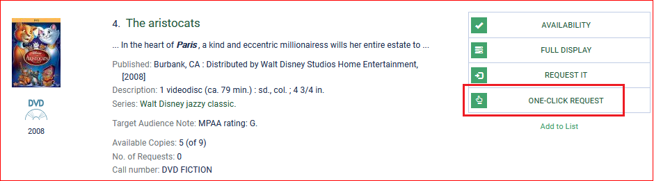

The activation date will be set to the current date and the pickup branch automatically becomes the customer’s default pickup library. Both settings can be changed by clicking View My Requests in the confirmation message:

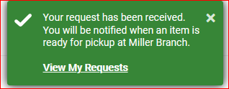

REMINDER: A hold request is not available for pickup until you receive a notification by email, phone, text message, or mail.

Additional Title Information
When available, Lexile reading levels and Goodreads ratings appear below the cover art in search results and full displays.

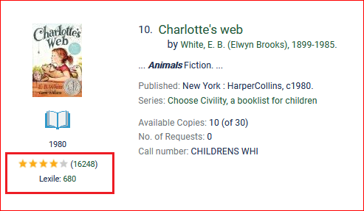

If all copies of a title are checked out, clicking on Similar Titles Available Now will provide a list of other available titles that may be of interest based on subject matter.

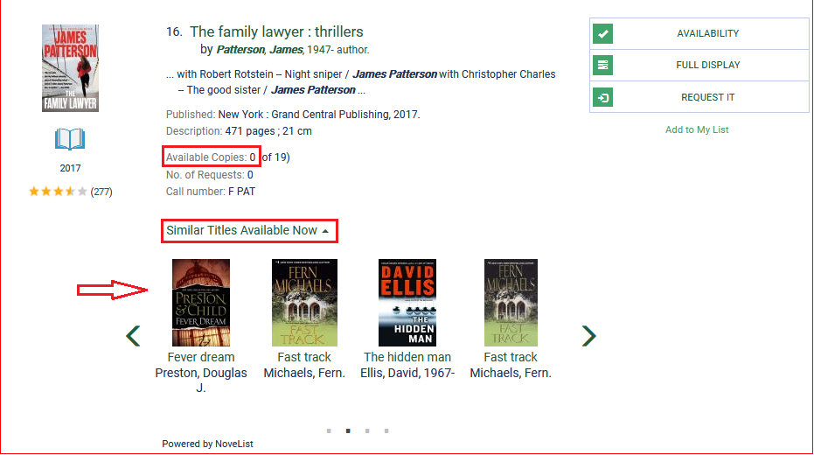

Cover Art in My Account
When available, cover art for titles listed in Items Out, Requests, Fines & Fees, and Reading History will display in My Account. The Format column and information icon have moved to the right side of the Requests list.

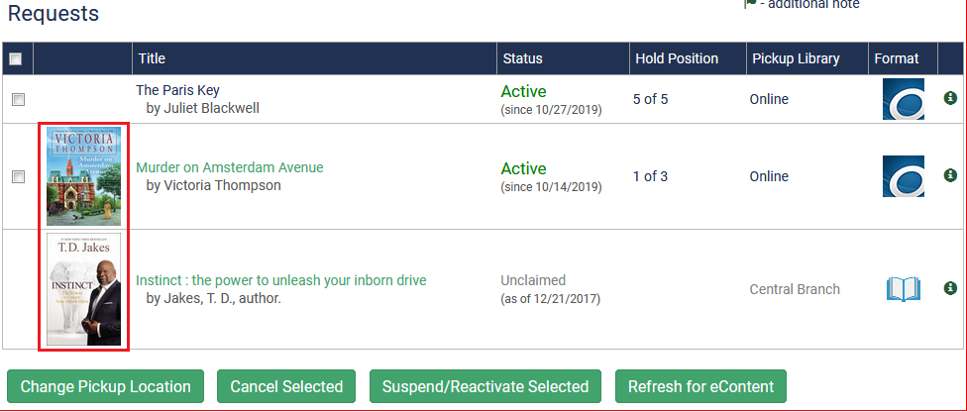

Notices
Call number and volume are now included on Hold and Items Due Soon notices sent by email and mail.

If you have any questions about the updated catalog, please ask one of the Library’s specialists.

